**43**

**Nuclear Physics**

|  |
| --- |
| **CHAPTER OUTLINE** |

43.1 Some Properties of Nuclei

43.2 Nuclear Binding Energy

43.3 Nuclear Models

43.4 Radioactivity

43.5 The Decay Processes

43.6 Natural Radioactivity

43.7 Nuclear Reactions

43.8 Nuclear Fission

43.9 Nuclear Reactors

43.10 Nuclear Fusion

43.11 Biological Radiation Damage

43.12 Uses of Radiation from the Nucleus

43.13 Nuclear Magnetic Resonance and Magnetic Resonance Imaging

* An asterisk indicates a question or problem new to this edition.

|  |
| --- |
| **ANSWERS TO THINK-PAIR-SHARE ACTIVITIES** |

**\*TP43.1 Conceptualize** Imagine the technical difficulties, and the cost, of extracting the uranium from the ocean water for Group (i) and for isolating the deuterium in the water from Group (ii). These considerations would have to be taken into account if a decision had to be made about which source to go after. We will ignore those considerations for now, however, and just determine the *existing* energy, without regard for how much of it is feasibly *available*.

**Categorize** We focus on the energy calculations for fission and fusion reactions in Sections 43.8 and 43.10.

**Analyze** Let’s begin with Group (i). We first find the amount of uranium in the ocean, based on the concentration density ** = 3.00 × 10–6 kg/m3. Using Equation 1.1,

 (1)

where *V* is the volume of the ocean. Evaluate the volume of the ocean, which will be needed by both groups, using the information given about the ocean in the problem statement:

 (2)

where *d* is the average depth of the ocean. Substitute numerical values:



Modify Equation (1) to represent the mass of *fissionable* uranium-235, using the fraction given in the problem statement:

 (3)

The energy that could be theoretically released from the fission of every  nucleus in the ocean is



where we have used the energy released per event from Example 43.9, *N* is the number of uranium-235 atoms in the ocean, and  is the atomic mass of uranium-235. Substitute numerical values:



Now, let’s consider the information for Group (ii). The statement “of all the hydrogen in the oceans, 0.030 0% of the mass is deuterium” can be expressed mathematically as

 (4)

where *m*H is the mass of all the hydrogen in the ocean. The mass of all the hydrogen in the ocean can be expressed as

 (5)

where the uppercase *M*s are molecular masses and  is the mass of all the water in the ocean. Using Equation 1.1,

 (6)

where *V* is the volume of the ocean. Combining Equations (4), (5), and (6), we have

 (7)

Now the number *N* of deuterons in this mass of deuterium is

 (8)

Because each fusion event requires two deuterons, the number of fusion events possible is

 (9)

The energy released per fusion event from the reaction assumed in the problem statement can be determined from Equation 43.30:



Therefore, the total energy released from the fusion of all deuterium in the ocean is, combining Equations (7) and (9),

 (10)

Substitute numerical values:



**Finalize** There is more energy in the oceans for fusion than fission by seven orders of magnitude! That’s the good news. The bad news is that fusion reactors are not yet a reality. If we do end up developing fusion reactors, we have a vast amount of energy available in seawater. At the current rate of world energy usage, the energy available for fusion in the oceans would last for 100 million years.]

*Answers:* Group (i): 2.44 × 1024 J; Group (ii): 2.60 × 1031 J

**\*TP43.2 Conceptualize** At first glance, we might say Patient A received twice as much as Patient B. But, reading onward, we see that the types of radiation are different and the mass of tissue irradiated is different. Maybe it’s not so clear cut.

**Categorize** We use the information in Section 43.11 on radiation dosage.

**Analyze** (a) Calculate first the dose in sieverts received by each patient using Equation 43.36:

Patient A: 

Patent B: 

Now, account for the mass of tissue involved to see which patient received the most energy:

Patient A: 

Patent B: 

Therefore, patient B received more energy than Patient A.

(b) Determine the ratio:



**Finalize** Therefore, Patient B received about 23% more radiation in terms of biological effectiveness than Patient A. It is interesting to point out that the radiation energy aimed at Patient A was larger than for Patient B: 2.0 Gy(0.022 kg) = 0.044 J compared to 1.0 Gy(0.030 kg) = 0.030 J. But, because of the RBE factor, the biological effectiveness was larger for Patient B.]

*Answers:* (a) Patient B (b) 1.023

**\*TP43.3** (a) The decay constant **, which is the probability of decay per throw, is one-sixth, because that is the probability of throwing a one on any die. Therefore, from Equation 43.8, the theoretical half-life is



As a result, when starting with 100 dice, somewhere between the 4th and 5th throws, the number of dice should pass from above 50 to below 50.

(b) Because 100 is a small number when dealing with statistics, this may not occur every time in practice. For example, the graph below shows some sample data. There is clearly a great deal of scatter in the data points. The experimental half-life, indicated by the dashed line, is about 4.3 throws. A better agreement between theory and experiment would result from a larger number of dice, say, 10 000, but that would be experimentally cumbersome! If you have some coding experience, you can set up a Monte Carlo simulation for 10 000 dice and test the results.

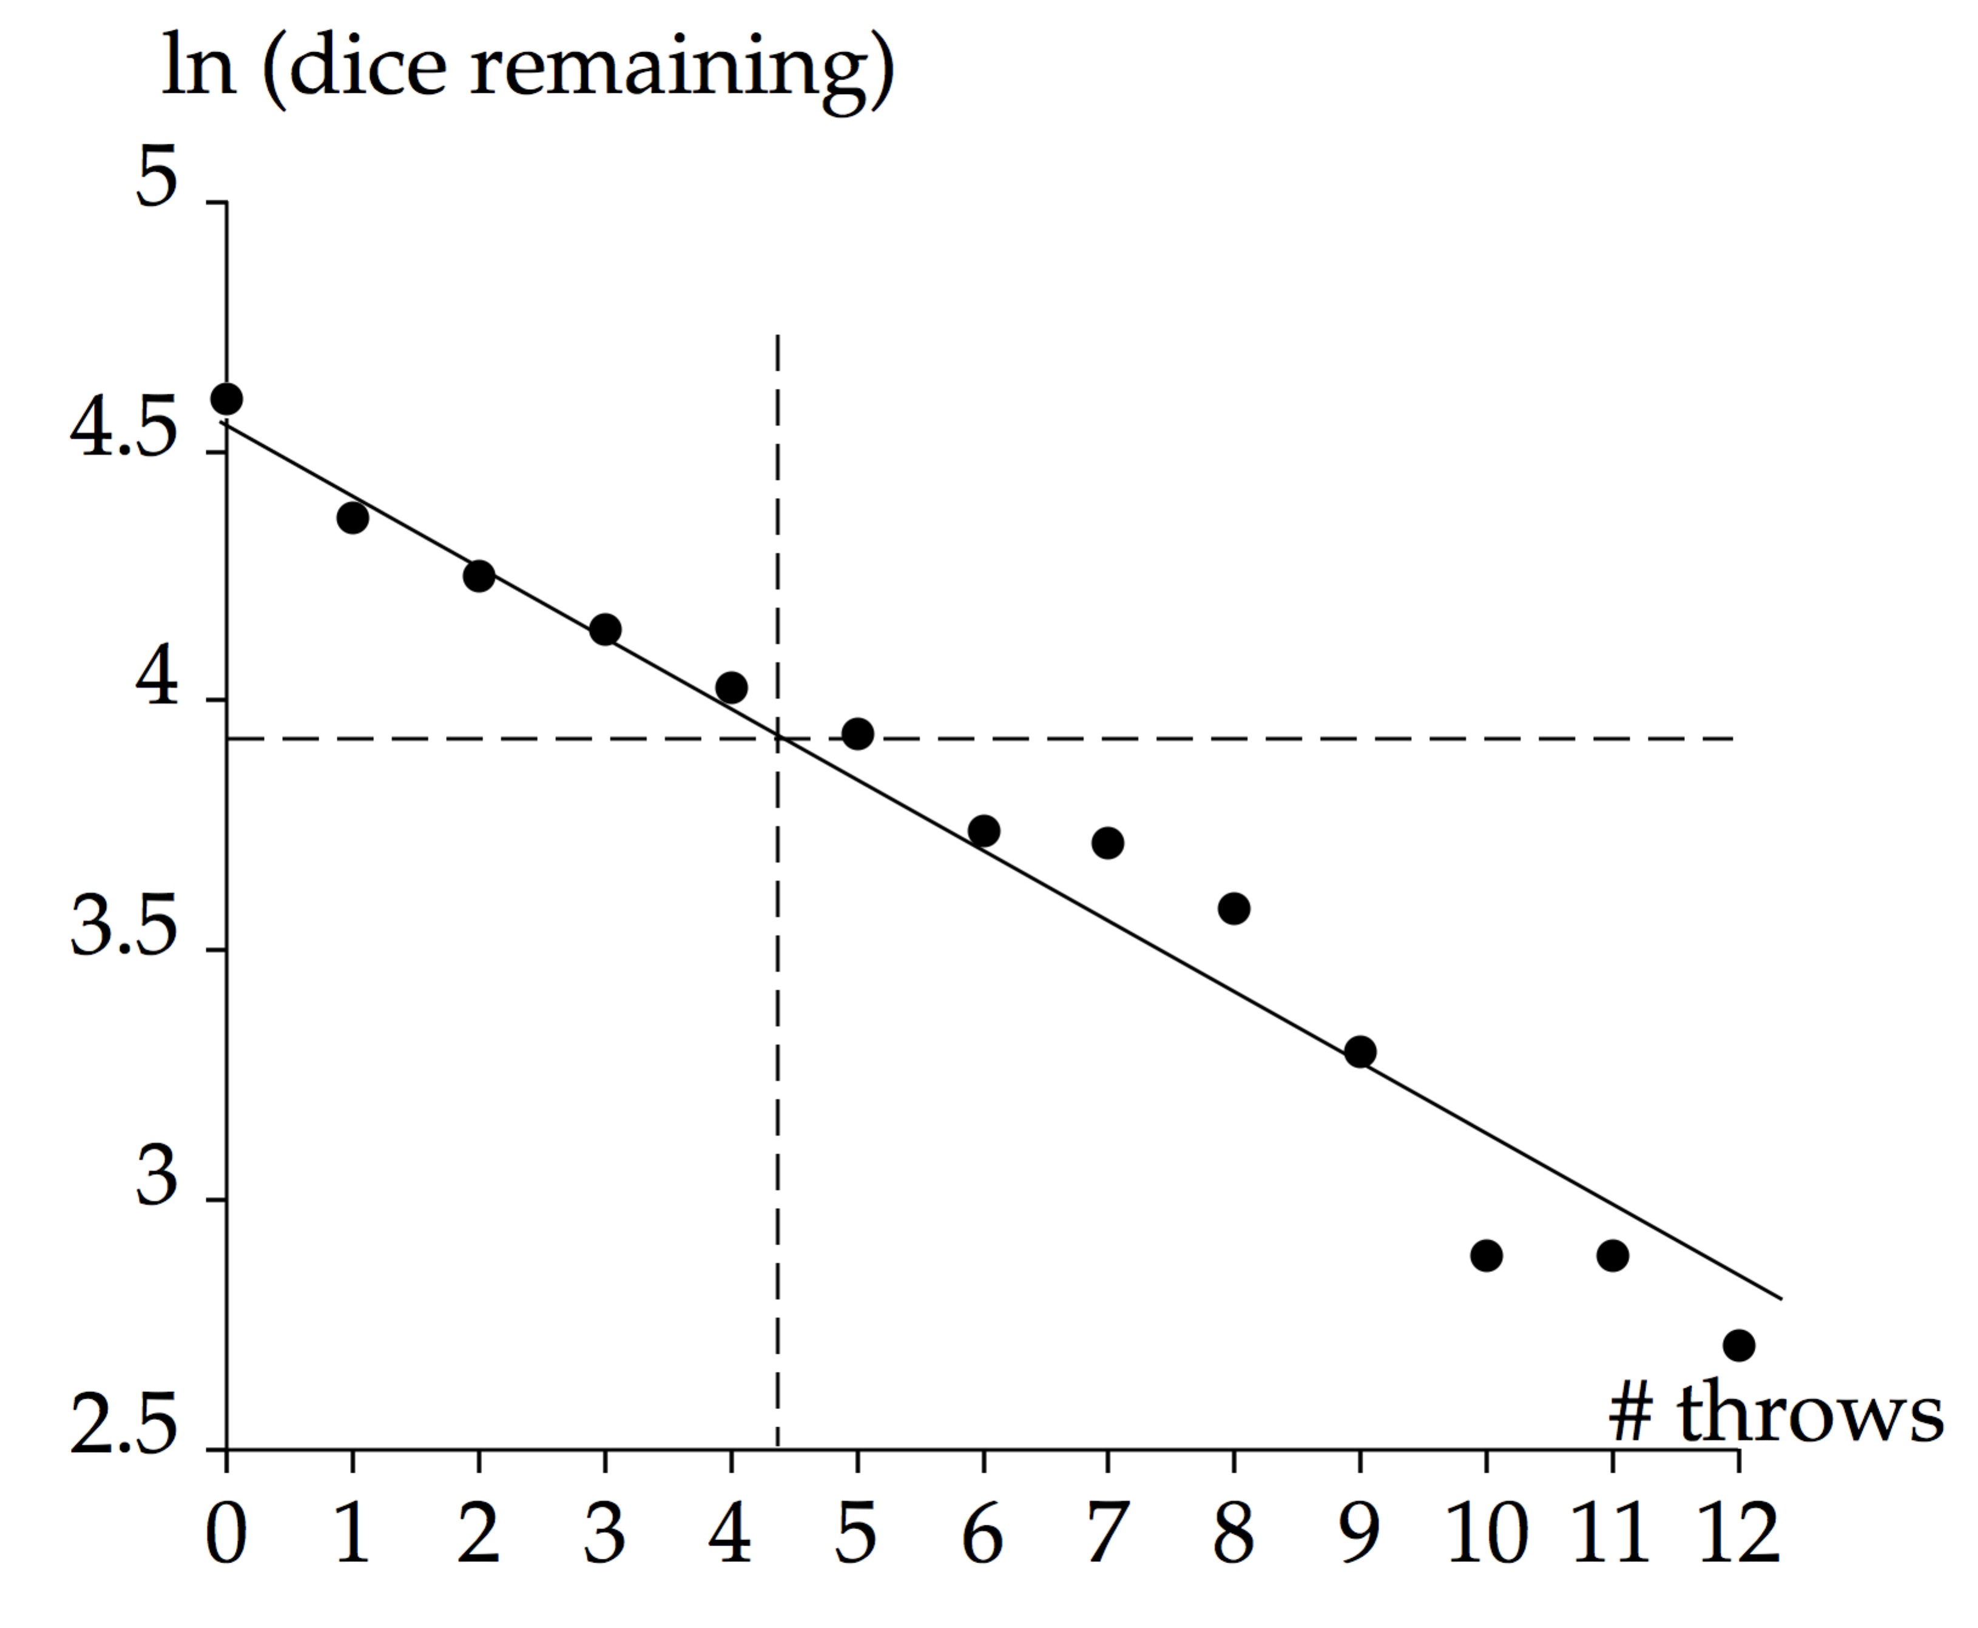]

*Answer:* (a) 4.16 throws (b) Answers will vary.

**SOLUTIONS TO END-OF-C**H**APTER**

**PROBLEMS**

|  |
| --- |
| **SOLUTIONS TO END-OF-CHAPTER PROBLEMS** |

**Section 43.1 Some Properties of Nuclei**

**P43.1** An iron nucleus (in hemoglobin) has a few more neutrons than protons, but in a typical water molecule there are eight neutrons and ten protons. So protons and neutrons are nearly equally numerous in your body, each contributing mass (say) 35 kg:

(a) 

(b) and 

(c) The electron number is precisely equal to the proton number, 

**P43.2** (a) Approximate nuclear radii are given by *r* = *r*0*A*1/3. Thus, if a nucleus of atomic number *A* has a radius approximately two-thirds that of  we should have



or 

(b) One possible nucleus is .

(c) 

**P43.3** (a) The electric potential energy between two protons is



(b) 

**P43.4** We obtain the alpha particle’s momentum from



(a) The de Broglie wavelength of the alpha particle is (mass from Table 43.1)



(b) Since *λ* is much less than the distance of closest approach, the alpha particle may be considered a particle.

**P43.5** (a) Let *V* represent the volume of the tank. The number of molecules present is



The volume of one molecule is



The volume of all the molecules is



So the fraction of the volume occupied by the hydrogen molecules is  An atom is precisely one half of a molecule.

(b) The fraction occupied by the nucleus is found from



In linear dimension, the nucleus is small inside the atom in the way a fat strawberry is small inside the width of the Grand Canyon. In terms of volume, the nucleus is *really* small.

**Section 43.2 Nuclear Binding Energy**

**\*P43.6 Conceptualize** Both nuclei have the same total number of nucleons, *A* = 15. We expect the binding energy to be greater for , because there will be fewer protons repelling each other.

**Categorize** We categorize this problem as a substitution problem.

Use Equation 43.2 to find a theoretical value of the binding energy for each nucleus:

 (1)

 (2)

Subtract Equation (2) from Equation (1):



Substitute numerical values:



The binding energy does indeed turn out to be higher for nitrogen.]

*Answer:* 3.54 MeV

**P43.7** We use Equation 43.2,



Then, for ,



and 

For ,



and 

The difference is



The binding energy per nucleon is greater for  by . There is less proton repulsion in  it is the more stable nucleus.

**P43.8** We find the mass difference,  and then the binding energy per nucleon, , in units of MeV. The results are tabulated below

|  |  |  |  |  |  |
| --- | --- | --- | --- | --- | --- |
| Nuclei | *Z* | *N* | *M* in u | in u | in MeV |
| 55Mn | 25 | 30 | 54.938 050 | 0.517 5 | 8.765 |
| 56Fe | 26 | 30 | 55.934 942 | 0.528 46 | 8.790 |
| 59Co | 27 | 32 | 58.933 200 | 0.555 35 | 8.768 |



**P43.9** (a) The isobar with the highest neutron-to-proton ratio is  the ratio is 

(b)  is stable, so has the largest binding energy per nucleon (8.378 MeV).

(c) The isobars are close in Figure 43.6, the plot of binding energy per nucleon versus mass number, and there is not much detail, so we may assume they have about the same binding energy, or missing mass. However, neutrons have more mass than protons, so the isobar with more neutrons (thus, fewer protons) should be more massive: 

**P43.10** (a) The radius of the 40Ca nucleus is,

 

The energy required to overcome electrostatic repulsion is



(b) The binding energy of  (*Z* = 20, *N = A – Z* = 20) is (using Equation 43.2 and masses from Table 43.2),



(c) 

**Section 43.3 Nuclear Models**

**P43.11** The curve of binding energy shows that a heavy nucleus of mass number *A* = 200 has binding energy about



Thus, it is less stable than its potential fission products, two middleweight nuclei of *A* = 100, together having binding energy



Fission then releases about



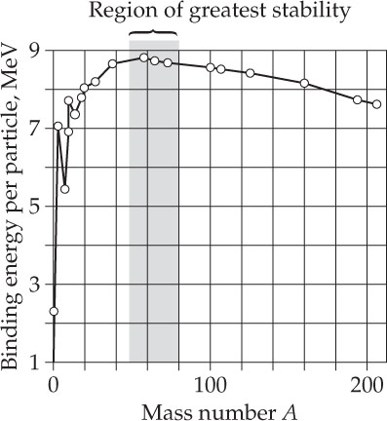

**ANS. FIG. P43.11**

**P43.12** (a) 

(b) The volume to surface ratio for a sphere of radius *r* is



The volume to surface ratio for a cube of side length *L* is





**Section 43.4 Radioactivity**

**P43.13** According to Equation 43.7, the time dependence of the decay rate is . From this equation we can derive a relation between the change in decay rate over the time interval  to the decay constant. We start with  Then, rearranging and taking the natural log of both sides gives



or 

Solving,



Now, because , we can relate the time interval to the half-life:



**\*P43.14 Conceptualize** 60Co decays by beta and gamma processes. The gamma rays are used medically. As the sample sits on the shelf, nuclei are decaying, so that the activity of the sample decreases. At some point, there is not enough activity for the sample to be effective for fighting the cancer cells.

**Categorize** The sample undergoes radioactive decay according to the principles outlined in Section 43.4.

**Analyze** We first find the number of years that have elapsed since the sample was delivered:

 (1)

Now use Equation 43.7 to find the fraction of the original nuclide still available:



This is just under the threshold of 60.0%, so it is probably best to discard this sample.

**Finalize** In Equation (1), we recognized that the period included a leap year by indicating that each year has 365.25 days. We subtracted 31 days because the time interval began on January 31 and ended on December 31. ]

*Answer:* Dispose of the sample.

**P43.15** The number of nuclei that decay during the interval will be



First we find the decay constant *λ*:



Now we find *N*0:



Substituting in these values,



**P43.16** The number of nuclei that decay during the interval will be



We wish to write this expression in terms of the half-life *T*1/2 and the initial decay rate *R*0. First, from the definition of *λ*, we have



Now we find *N*0:



Substituting in these expressions, we find that



**P43.17** (a) From Equation 43.6, the fraction remaining at *t* = 5.00 yr will be



(b) At *t* = 10.0 yr,



(c) At *t* = 123.3 yr,



(d) 

**P43.18** (a)  rate of change of *N*2

= rate of production of *N*2 – rate of decay of *N*2

= rate of decay of *N*1 – rate of decay of *N*2



(b) From the trial solution,



 **[1]**



So  as required.

(c) The functions plotted in ANS. FIG. P43.18(c) are



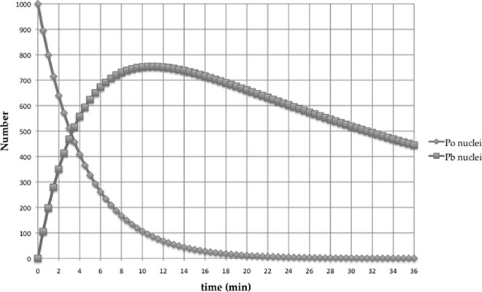

**ANS. FIG. P43.18(c)**

(d) From the graph, 

(e) From equation [1],  if





Thus, .

(f) With , , this formula gives



This result is in agreement with the result of part (d).

**Section 43.5 The Decay Processes**

**P43.19** Atomic masses are given in Table 43.2.

(a) For this e+ decay,



Since *Q* < 0, the decay  spontaneously.

(b) For this alpha decay,



Since *Q* < 0, the decay  spontaneously.

(c) For this alpha decay,



Since *Q* > 0, the decay  spontaneously.

**P43.20** Total *Z* and *A* are conserved.

(a) A gamma ray has zero charge and it contains no protons or neutrons. So for a gamma ray *Z* = 0 and *A* = 0. Keeping the total values of *Z* and *A* for the system conserved requires *Z* = 28 and *A* = 65 for X. With this atomic number it must be nickel, and the nucleus must be in an excited state, so X is 

(b) An alpha particle,  has *Z* = 2 and *A* = 4. Total initial *Z* is 84, and total initial *A* is 215, so for X we require

*Z* = 84 = *Z*X + 2 → *Z*X = 82 → Pb, and

*A* = 215 = *A*X + 4 → *A*X = 211, → X is .

(c) A positron, , has charge the same as a nucleus with *Z* = 1. A neutrino,  has no charge. Neither contains any protons or neutrons. So X must have by conservation *Z* = 26 + 1 + 0 = 27; so, X is Co. And *A* = 55 + 0 + 0 = 55: X is 

**P43.21** (a) The reaction for one particle is .

(b) For nuclei, 

Add seven electrons to both sides to obtain



From Table 44.2 of atomic masses,



**P43.22** (a) The decay constant is *λ =* ln2/10 h = 0.0693/h. The number of parent nuclei is given by , where *t* is in hours.

The number of daughter nuclei is equal to the number of missing parent nuclei,



(b) 

(c) 

(d) The rate of change is



where  is in decays per hour and *t* is in hours. The rate of change has its maximum value, 6.93 × 104 h–1, at *t* = 0, after which the rate decreases more and more, approaching zero as *t* increases without limit.

**P43.23** (a) The number of carbon atoms in the sample is



(b) 1 in 7.70 × 1011 carbon atoms is a 14C atom. Then,



(c) The decay constant for 14C is



(d) We use  At *t* = 0,



(e) At time *t*, 

(f) Taking logarithms,

 so 

and



**Section 43.6 Natural Radioactivity**

**P43.24** The number of radon atoms remaining is



And the fraction remaining is



(a) With *T*1/2 = 3.82 d and *t* = 7.00 d,



(b) When *t* = 1.00 yr = 365.25 d,



(c)  as one daughter in the series of decays starting from the long-lived isotope 238U.

**P43.25** We find the chemical name by looking up *Z* in a periodic table. The values in the shaded boxes  in Figure P43.25 were given; all others have been filled in as part of the solution shown in ANS. FIG. P43.25 below.

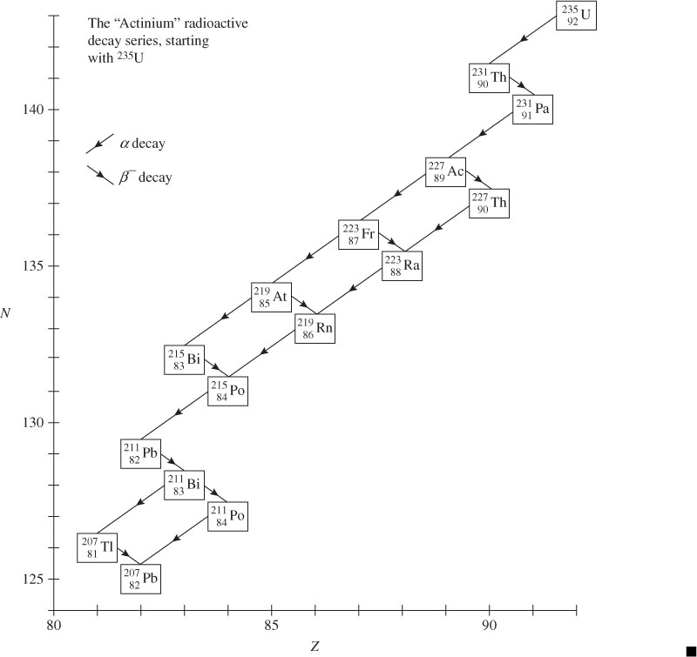

**ANS. FIG. P43.25**

**Section 43.7 Nuclear Reactions**

**P43.26** (a) 

Note the conservation of baryon number (which you can think of as nucleon census number and call mass number in this chapter) in the superscripts: 197 + 1 = 198 + 0. Note the conservation of charge in the subscripts: 79 + 0 = 80 – 1.

(b) Consider adding 79 electrons:



Then,



**P43.27** Total *A* and total *Z* are conserved.

(a) For *X*, *A* = 24 + 1 – 4 = 21 and *Z* = 12 + 0 – 2 = 10, so *X* is 

(b) *A* = 235 + 1 – 90 – 2 = 144 and *Z* = 92 + 0 – 38 – 0 = 54,   
so *X* is 

(c) *A* = 2 – 2 = 0 and *Z* = 2 – 1 = +1, so *X* must be a positron.

As it is ejected, it is accompanied by a neutrino:



**Section 43.8 Nuclear Fission**

**P43.28** Three different fission reactions are possible:







**P43.29** First, the thorium is bombarded:



Then, the thorium decays by beta emission:



Protactinium-233 has more neutrons than the more stable protactinium-231, so it too decays by beta emission:



**Section 43.9 Nuclear Reactors**

**P43.30** (a) For a sphere: , so



(b) For a cube: , so



(c) For a parallelepiped: , so



(d) The answers show that the sphere has the smallest surface area for a given volume and the brick has the greatest surface area of the three. Therefore, The sphere has minimum leakage and the parallelepiped has maximum leakage.

**P43.31** (a) Do not think of the “reserve” as being held in reserve. We are depleting it as fast as we choose. The remaining current balance of irreplaceable 235U is 0.7% of the whole mass of uranium:



(b) The number of moles of 235U in the reserve is



(c) The number of moles found in part (b) corresponds to



(d) We imagine each nucleus as fissioning, to release



(e) The definition of power is represented by   
P = (energy converted)/, so we have



(f) 

**P43.32** Assuming that the impossibility is *not* that he can have this control over the process (which, as far as we know presently, *is* impossible), let’s see what else might be wrong. The reaction can be written



where *n* is the number of neutrons released in the fission reaction. By balancing the equation for electric charge and number of nucleons, we find that *n* = 1. If one incoming neutron results in just one outgoing neutron, the possibility of a chain reaction is not there, so this nuclear reactor will not work.

**P43.33** (a) Since *K* = *p*2/2*m,* we have



(b) The de Broglie wavelength of the particle is



(c) 

**Section 43.10 Nuclear Fusion**

**\*P43.34 Conceptualize** The Sun has a mass of 1.99 × 1030 kg, from Table 13.2, and the total power output of 3.85 × 1026 W is easily found online.

**Categorize** This problem involves a calculation of the time interval knowing the power and the total energy.

**Analyze** (a) From the definition of power, find the time interval for a certain amount of energy to be transformed:

 (1)

If the Sun is formed entirely from gasoline, let’s find the available energy:



where *RS* is the radius of the Sun. Using the value from Table 13.2, we have



Substitute numerical values into Equation (1):



(b) Now imagine that the Sun is made up entirely of protons. The effect of the fusion reaction is to combine four protons into a helium nucleus, so the energy released in this reaction is



Now, the number of possible reactions is equal to the number of protons divided by 4, since we need four for each reaction:



Therefore, the total available energy output is



Substitute numerical values into Equation (1):



**Finalize** In part (a), the Sun only lasts for 4 000 years. We know that the Sun has been around longer than that! In part (b), we have a more reasonable estimate of 100 billion years, although this value is too high because only the central core of the Sun has the required temperatures and densities for nuclear fusion to occur. The current age of the Sun is estimated to be about 4.6 billion years, and we appear to be about halfway through its lifetime.]

*Answers:* (a) 4.0 × 103 yr (b) 1.0 × 1011 yr

**P43.35** (a) The radius of a nucleus with mass number *A* is *r* = *aA*1/3, where   
*a* = 1.2 fm. The distance of closest approach is equal to the center to center distance of the two nuclei:



(b) At this distance, the electric potential energy is



(c) Conserving momentum,  or



(d) To find the minimum initial kinetic energy of the deuteron, we use *Ki* + *Ui* = *Kf* + *Uf* , where *Ui* = 0 because the deuteron starts from very far away (infinity), and with the result from part (c),



With some re-arrangement, we have



or



solving for the initial kinetic energy then gives



(e) The nuclei can fuse possibly by tunneling through the potential energy barrier.

**P43.36** (a) We assume that the nuclei are stationary at closest approach, so that the electrostatic potential energy equals the total energy *E*. Then, from the isolated system model,



then,





or *E* = 144Z1Z2 where *E* is in keV.

(b) The energy is proportional to each atomic number.

(c) Take *Z*1 = 1 and *Z*2 = 59 or vice versa. This choice minimizes the product *Z*1 *Z*2. If extra cleverness is allowed, take *Z*1 = 0 and   
*Z*2 = 60: use neutrons as the bombarding particles. A neutron is a nucleon but not an atomic nucleus.

(d) For both the D-D and the D-T reactions, *Z*1 = *Z*2 = 1. Thus, the minimum energy required in both cases is



Section 43.10 in the text gives more accurate values for the critical ignition temperatures, of about 52 keV for D-D fusion and 6 keV for D-T fusion. The nuclei can fuse by tunneling. A triton moves more slowly than a deuteron at a given temperature. Then D-T collisions last longer than D-D collisions and have much greater tunneling probabilities.

**P43.37** (a) Taking *m*  2*mp* for deuterons, we have



The root-mean-square speed is



(b) The confinement time in the absence of confinement measures is



**P43.38** (a) By adding 1 + 6 = 7 and 1 + 12 = 13, we have  so nucleus A is 13N.

(b) Now 13 – 0 = 13 and 7 – 1 = 6, so the positron decay is  and nucleus B is 13C.

(c) Similarly, we have  and nucleus C is 14N.

(d) The hydrogen nuclei keep piling on like rugby players after a tackle. We have  and nucleus D is 15O.

(e) Now  so nucleus E is 15N.

(f) We calculate 15 + 1 – 4 = 12 and 7 + 1 – 2 = 6 to identify  and nucleus F is 12C.

(g) The original carbon-12 nucleus is returned. One carbon nucleus can participate in the fusions of colossal numbers of hydrogen nuclei, four after four. Carbon is a catalyst.

The two positrons immediately annihilate with electrons according to  The overall reaction, obtained by adding all eight reactions, can be represented as



This simplifies to  The net reaction is identical to the net reaction in the proton–proton cycle which predominates in the Sun. In energy terms the reaction can be considered as  where the Q value of energy output was computed in Chapter 38.

**Section 43.11 Biological Radiation Damage**

**P43.39** (a) The number of x-ray images made per year is (assuming a 2-week vacation)



The average dose per photograph is



(b) The technician receives low-level background radiation at a rate of 0.13 rem/yr. The ration dose of 5.0 rem/yr received as a result of the job to background is





**P43.40** Assume all the energy from the x-ray machine is absorbed by the water and that no energy leaves the cup of water by heat or thermal radiation. The energy input to the cup and the temperature of the water are related by

**

Because the power input *P* is equal to  we have



where we have solved for the time interval required to raise the temperature of the water. We note that the temperature of the water will increase until it is 100°C, after which the latent heat of vaporization of  would have to be added to boil the water. For the purposes of this problem, we limit ourselves to increasing the temperature of the water to 100°C. Substituting numerical values gives



Therefore, it would take over 24 days just to increase the water’s temperature to 100°C, and much longer to boil it, and this technique will not work for a 20-minute coffee break!

**P43.41** The nuclei initially absorbed are (mass from Table 43.2)



The number of decays in time *t* is



At the end of 1 year,



The energy deposited is

 

Thus, the dose received is



**Section 43.12 Uses of Radiation from the Nucleus**

**P43.42** (a) Starting with *N* = 0 radioactive atoms at *t* = 0, the rate of increase is (production – decay)

 so 

The variables are separable.



so 

Therefore 

(b) The maximum number of radioactive nuclei would be .

**P43.43** (a) The number of photons is  Since only 50% of the photons are detected, the number of 65Cu nuclei decaying is twice this value, or 1.92 × 104. In two half-lives, three-fourths of the original nuclei decay, so  and *N*0 = 2.56 × 104. This is 1% of the 65Cu, so the number of 65Cu is .

(b) Natural copper is 69.17% 63Cu and 30.83% 65Cu. Thus, if the sample contains *N*Cu copper atoms, the number of atoms of each isotope is *N*63 = 0.691 7 *N*Cu and *N*65 = 0.308 3 *N*Cu. Therefore,



or 

The total mass of copper present is then



**Section 43.13 Nuclear Magnetic Resonance and Magnetic Resonance Imaging**

**P43.44** It is the quantum particle under boundary conditions model that is behind the general rules: With angular momentum quantum number I, the magnitude of the angular momentum must be . Whether I is an integer or a half-integer, the allowed values for one component of angular momentum being measured range from  to +(I – 1) to … to . Conditions that the wave function for a quantum particle must satisfy, for self-consistency under rotations in three-dimensional space, impose these requirements. We call a component being measured the z component. It can be measured more directly, as in a nuclear magnetic resonance experiment, or less directly, as from the way the angular momentum influences the intrinsic energy levels of a system and the number of available states within an energy level.

(a) With I = 5/2, the magnitude of the angular momentum is



The z component can take the values +5, +3, +, , , and . These identifications are shown in ANS. FIG. P43.44(a).

(b) Similarly, with I = 4, the magnitude of the angular momentum of a nucleus is  and its z component must have one of the nine values +4, +3, +2, , 0, , –2, –3, –4, as shown in ANS. FIG. P43.44(b).

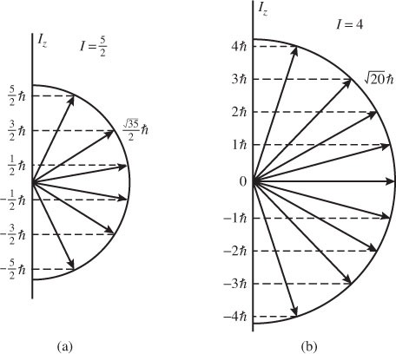

**ANS. FIG. P43.44**

**Additional Problems**

**P43.45** (a) The process cannot occur because energy input would be required. Note that the mass of the proton is less than the sum of the masses of the neutron and positron (electron):



Therefore, the reaction  would violate the law of conservation of energy.

(b) The of protons in the parent nucleus.

(c) Add seven electrons to both sides of the reaction for nuclei  to obtain the reaction for neutral atoms 



**P43.46** The proposed reaction can be written as



While electric charge is conserved (5 + 2 = 1 + 6), the number of nucleons is not (10 + 4 ≠ 1 + 12). Therefore, this reaction cannot occur.

**P43.47** (a) The energy released by the  reaction is





(b) 

**P43.48** We check the *Q* value of this reaction:





**P43.49** (a) If  is the energy difference between the excited and ground states of the nucleus of mass *M*, and *hf* is the energy of the emitted photon, conservation of energy for the nucleus-photon system gives

 **[1]**

where  is the recoil energy of the nucleus, which can be expressed as

 **[2]**

Since system momentum must also be conserved, we have

 **[3]**

Hence, can be expressed as .

When  we can make the approximation that 

so 

(b) ,  where  

and 

Therefore,



**P43.50** (a) If we assume all the  came from then  yields



where 

and 



(b) It could be  The rock could be younger if some were originally present. We must make some assumption about the original quantity of radioactive material. In part (a) we assumed that the rock originally contained no strontium.

**P43.51** (a) For the electron capture,



For positron emission,



The daughter nucleus in both forms of decay is.

(b) We usually calculate the *Q* value under the assumption that the daughter nucleus is in its ground state, but for these decays, the *Q* value gives the upper limit of energy available to the daughter nucleus to be above its ground state.

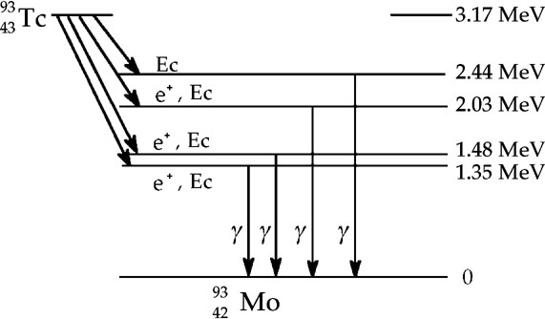

**ANS. FIG. P43.51**

For electron capture, the disintegration energy is





so electron capture provides enough energy for  to be in all levels above its ground state.

For  emission, the disintegration energy is

.



so  emission does not supply enough energy for  to be in the 4.22 MeV state, only 1.35 MeV, 1.48 MeV, and 1.35 MeV above ground (see ANS. FIG. P43.51).

**P43.52** We check the *Q* value of the 57Co nuclei decay by e+:



Mass values appear in Table 43.2. For this reaction,





**P43.53** (a) With  and  as the mass and speed of the neutrons, Equation 9.24 for elastic collisions becomes for the two collisions, after making appropriate notational changes,

, and 

Solving,



(b) We obtain the neutron mass from



**P43.54** (a) We treat the collision of the two particles a and X as a perfectly inelastic collision: the kinetic energy that is converted into internal energy supplies the missing energy *Q*, permitting the conversion of the particles into Y and b.

Initially, the projectile  moves with velocity  while the target  is at rest. We have from momentum conservation for the projectile-target system:



The initial energy is



The final kinetic energy is:



From this, we see that  is always less than  and the change in energy, , is given by



This loss of kinetic energy in the isolated system corresponds to an increase in mass-energy during the reaction. Thus, the absolute value of this kinetic energy change is equal to –*Q* (remember that *Q* is negative in an endothermic reaction). The initial kinetic energy is the threshold energy  Therefore,



or .

(b) We first calculate the *Q* value for the reaction:





Then,



**P43.55** We have the following information: 

 The nuclei decay exponentially:



Taking the natural logarithm of both sides,



The half-life of X is 

**P43.56** We have the following information: and  The nuclei decay exponentially:



Taking the natural logarithm of both sides,





The half-life of X is 

**P43.57** (a) Subtracting the background counts, the decay counts are   
*N*1 = 372 – 5(15) = 297 in the first 5.00 min interval and   
*N*2 = 337 – 5(15) = 262 in the second. The midpoints of the time intervals are separated by *T* = 5.00 min. We use  taking *t* = *T* and identifying *R*0 = *N*1/*T* = 297/5 minand*R* = *N*2/*T* = 262/5 min.We have then



which gives



Solving,



The half-life is then



NOTE: If it seems questionable to set instantaneous decay rates equal to average decay rates, to let *R*0 = *N*1/*T* and *R* = *N*2/*T*, see the Alternate Solution to (a) below. The results are the same.

(b) The average count rate is about



but the counts are randomly spaced in time, meaning some counts near the beginning and end of each 5.00-min interval should or should not have been counted. Let’s assume that the count incidence could vary by as much as 5 seconds, so we shall assume a count uncertainty of ±5. The smallest likely value for the half-life is then given by

, giving 

The largest credible value is found from

, yielding 

Thus, the half-life is about



Alternate Solution to (a) The amount of the radioactive sample at time *t* is , where we do not know *N*0. The number of decay counts between *t* = 0 and *t* = *T* are



and the number of decay counts between *t* = 0 and *t* = 2*T* are



To eliminate *N*0, we consider the ratio of the counts:



solving,



which leads to the same result as above, .

**P43.58** (a) To conserve momentum, the two fragments must move in opposite directions with speeds v1 and v2 such that

m1v1 = m2v2 or 

The kinetic energies after the break-up are then

 and 

The fraction of the total kinetic energy carried off by m1 is



and the fraction carried off by m2 is



(b) The disintegration energy is



(c) Immediately after fission, this *Q*-value is the total kinetic energy of the fission products. From part (a),



Then,



and 

(d) The speed of the fragments is given by



and



**P43.59** The complete fissioning of 1.00 gram of 235U releases



If all this energy could be utilized to convert *m* kilograms of 20.0°C water to 400°C steam (see Chapter 19 of text for values), then



Therefore, 

**P43.60** When mass *m* of 235U undergoes complete fission, releasing energy *E* per fission event, the total energy released is



where *NA* is Avogadro’s number. If all this energy could be utilized to convert a mass *mw* of liquid water at *Tc* into steam at *Th*, then



where *cw* is the specific heat of liquid water, *Lv* is the latent heat of vaporization, and *cs* is the specific heat of steam. Solving for the mass of water converted gives



**P43.61** (a)  and







Thus, reactions may be added. Any product like C used in a subsequent reaction does not contribute to the energy balance.

(b) Adding all five reactions gives





Adding two electrons to each side gives



Thus,



**P43.62** (a) From the definition of the volume of a cube and the definition of mass density, we have , so

 

(b) We add 92 electrons to both sides of the given nuclear reaction. Then it becomes



The *Q* value of this reaction is



(c) 

(d) The decay rate for all steps in the radioactive series in steady state is set by the parent uranium:



The decay constant is



and the rate of decays is then



so, 

(e) We know that

dose in rem = dose in rad × RBE

or

5.00 rem/yr = (dose in rad/yr)(1.10)

giving

(dose in rad/yr) = 4.55 rad/yr

The allowed whole-body dose is then



**P43.63** (a) We have 1.00 kg – (1.00 kg)(0.007 20) – (1.00 kg)(0.000 0500) =   
0.993 kg of 238U, comprising



with activity



We have (1.00 kg)(0.007 20) = 0.007 2 kg of 235U, comprising



with activity



We have (1.00 kg)(0.000 0500) = 5.00 × 10–5 kg of 234U, comprising



with activity



(b) The total activity is (330 + 16 + 310) *µ*Ci = 656 *µ*Ci, so the fractional contributions are, respectively, 330/656 = 50%, 16/656 = 2.4%, and 310/656 = 47%

(c) 

**P43.64** (a) From the given equation, the ratio of the two intensities is



(b) Substituting numerical values into the equation in part (a) gives



(c) Here, *x* = 10.0 mm = 1.00 cm, and



Thus, a 1.00-cm-thick aluminum plate has essentially removed the long-wavelength x-rays from the beam.

**P43.65** (a) The number of Pu nuclei in 1.00 kg is



The total energy is





or 22 million kWh.

(b) 



(c) 



(d) 



(e) 

**Challenge Problems**

**P43.66** The electric charge density in the sphere is



Using Gauss’s Law inside the sphere,

:

or 

Outside the sphere, the field is



We now find the electrostatic energy





or 

|  |
| --- |
| **ANSWERS TO QUICK-QUIZZES** |

**1. (i)** (b) **(ii)** (a) **(iii)** (c)

**2.** (e)

**3.** (b)

**4.** (c)

**5.** (b)

**6.** (a), (b)

**7.** (d)

|  |
| --- |
| **ANSWERS TO EVEN-NUMBERED PROBLEMS** |

**P43.2** (a) 68; (b); (c) Isotopes of other elements to the left and right of zinc in the periodic table (from manganese to bromine) may have the same mass number.

**P43.4** (a) 5.18 fm; (b) 

**P43.6** 3.54 MeV

**P43.8** 

**P43.10** (a) 84.2 MeV; (b) 342 MeV; (c) The nuclear force is so strong that the binding energy greatly exceeds the minimum energy needed to overcome electrostatic repulsion.

**P43.12** (a) Nucleons on the surface have fewer neighbors with which to interact. The surface term is negative to reduce the estimate from the volume term, which assumes that all nucleons have the same number of neighbors; (b) sphere,  cube,  The sphere has a larger ratio to its characteristic length, so it would represent a larger binding energy and be more plausible for a nuclear shape.

**P43.14** Dispose of the sample.

**P43.16** 

**P43.18** (a) See P43.18(a) for full explanation; (b) See P43.18(b) for full explanation; (c) See ANS. FIG. P43.18(c); (d) 10.9 min;   
(e) ; (f) 10.9 min

**P43.20** (a) (b) (c) 

**P43.22** (a), where *t* is in hours;   
(b) The number of daughter nuclei starts from zero at *t* = 0. The number of stable product nuclei always increases with time and asymptotically approaches 1.00 × 106 as *t* increases without limit;   
(c) The minimum number of daughter nuclei is zero at *t* = 0. The maximum number of daughter nuclei asymptotically approaches   
1.00 × 106 as *t* increases without limit; (d) The rate of change has its maximum value, 6.93 × 104 h–1, at *t* = 0, after which the rate decreases more and more, approaching zero as *t* increases without limit.

**P43.24** (a) 0.281; (b); (c) Radon is continuously created.

**P43.26** (a)  (b) 7.89 MeV

**P43.28** , , 

**P43.30** (a)  (b) ** (c) ** (d)The sphere has minimum leakage and the parallelepiped has maximum leakage

**P43.32** See P43.32 for full explanation

**P43.34** (a) 4.0 × 103 yr (b) 1.0 × 1011 yr

**P43.36** (a) *E* = 144*Z*1*Z*2 where E is in keV; (b) The energy is proportional to each atomic number; (c) Take *Z*1 = 1 and *Z*2 = 59 or vice versa. This choice minimizes the product *Z*1 *Z*2; (d) 144 keV for both, according to this model

**P43.38** (a) ; (b) ; (c) ; (d) ; (e) ; (f) ; (g) The original carbon-12 nucleus is returned so the overall reaction is 

**P43.40** It would take over 24 days to raise the temperature of the water to 100°C and even longer to boil it, so this technique will not work for a 20-minute coffee break!

**P43.42** (a) See P45.44(a) for full explanation; (b) 

**P43.44** (a) See ANS. FIG P43.44 (a); (b) See ANS. FIG P43.44 (b)

**P43.46** See ANS. P43.46 for full explanation

**P43.48**



**P43.50** (a) ; (b) no older

**P43.52** 

**P43.54** (a) See ANS. P43.54(a) for full explanation; (b) 1.53 MeV

**P43.56** 

**P43.58** (a) See P43.58(a) for full explanation; (b) 177 MeV; (c) *K*Br = 112.0 MeV, *K*La = 65.4 MeV; (d) *v*Br = 15.8 Mm/s, *v*La = 9.30 Mm/s

**P43.60** 

**P43.62** (a) 15.4 cm; (b) 51.7 MeV; (c) The number of decays per second is the decay rate *R,* and the energy released in each decay is *Q*. Then the energy released per unit time interval is *P* = *QR*; (d) 2.27 × 105 J/yr;   
(e) 3.18 J/yr

**P43.64** (a) ; (b) 35.2; (c) 

**P43.66 **